Alexander Baldree
08/19/26
Module 3.2 Assignment
CSD440

GitHub Link: https://github.com/Panda-Alex21687/CSD440

XAMPP Installed and Running:
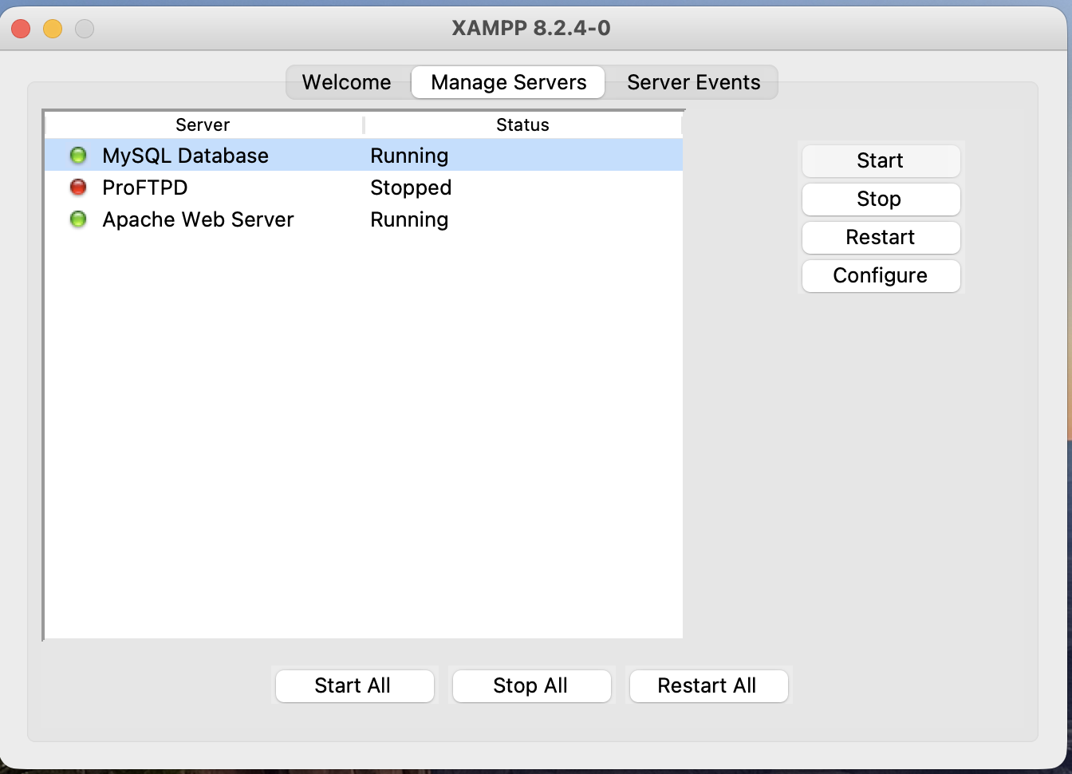

XAMPP files in Visual Studio:
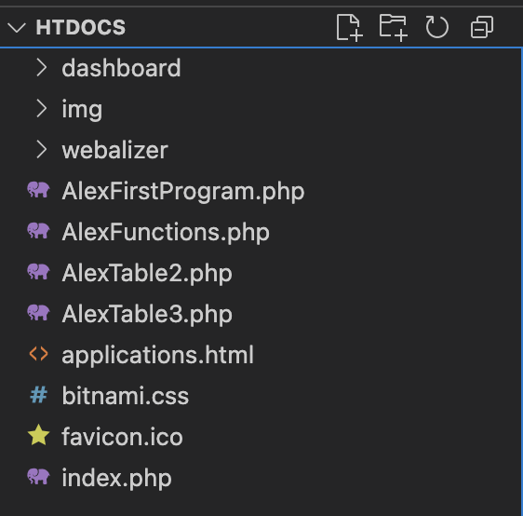

Running on LocalHost:
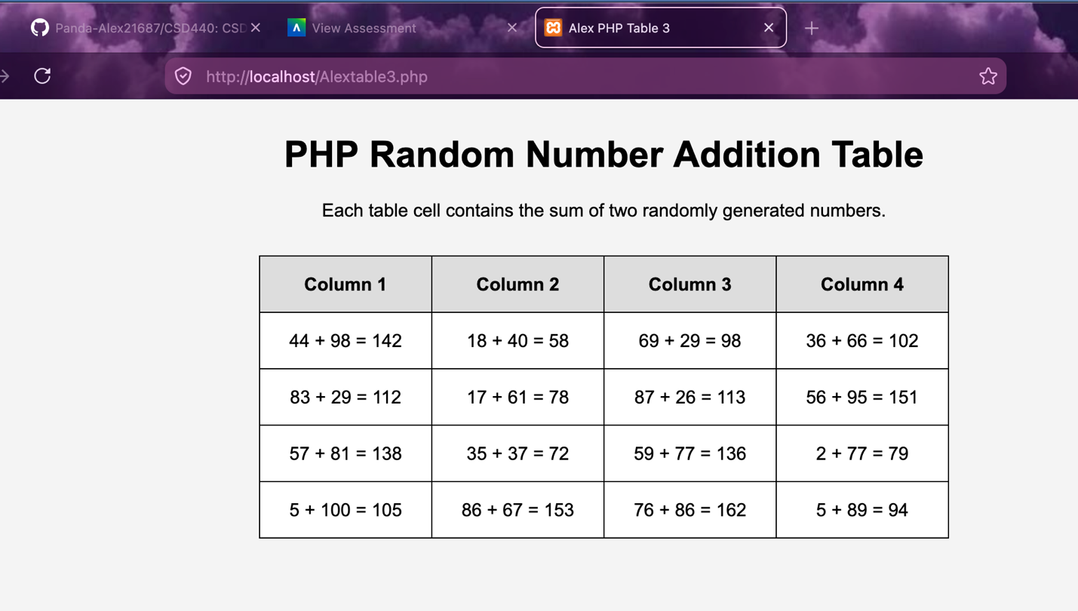
Refreshed:
